Stem Cells
- State the definition of a stem cell.
_____________________________________________________________________________
_____________________________________________________________________________
_____________________________________________________________________________

- Describe where stem cells can be found.
_____________________________________________________________________________
_____________________________________________________________________________
_____________________________________________________________________________

- Cells in the human body are specialised to carry out their particular function.
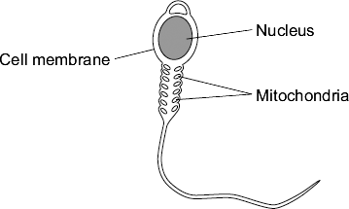
The diagram shows a sperm cell.

- Describe and explain how the sperm cell is adapted for its function.

_____________________________________________________________________________
_____________________________________________________________________________
_____________________________________________________________________________

- Describe how the nucleus of the sperm cell is different to the nucleus of a body cell.
_____________________________________________________________________________
_____________________________________________________________________________
_____________________________________________________________________________

The diagram shows one way that stem cells can be produced from human embryos.

- Embryonic stem cells can be used to treat a condition such as paralysis.
Explain why.
_____________________________________________________________________________
_____________________________________________________________________________
_____________________________________________________________________________

- During pregnancy, an umbilical cord and a placenta join the embryo to the mother.
At birth the umbilical cord is cut. Stem cells can be obtained from the umbilical cord.

Many people think that the stem cells for treating human conditions should be obtained from umbilical cords rather than human embryos.

Suggest a reason why.

_____________________________________________________________________________
_____________________________________________________________________________
_____________________________________________________________________________

- Meristems can be used to clone plants that are at risk of extinction. Explain why this may be important for ecosystems.

_____________________________________________________________________________
_____________________________________________________________________________
_____________________________________________________________________________

- Complete the table to show the advantages and disadvantages of embryonic stem cells and adult bone marrow stem cells.

 | Advantages | Disadvantages
Embryonic Stem Cells
Adult Bone Marrow Stem Cells

Stretch Activity:
During George W. Bush’s Presidency of the United States embryonic stem cell research was prohibited. Discuss the possible effects of this on Scientific research.

